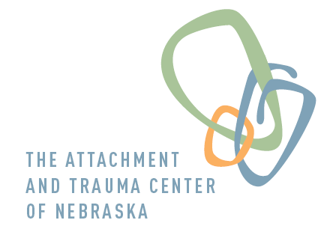638 N 109th Plz  Omaha NE 68154  (402) 403-0190  FAX (402) 932-4121

Teen DBT – Coping Skills Group

Mondays 4-530 PM
For Teens (aged 13-19) struggling with:
Difficulty managing emotions Interpersonal problems
Suicidal thoughts/behavior Self-Harm
Impulsivity Anger and aggressive behavior

Teen DBT Group includes:
Family Intake Session
Weekly skill-building sessions: Mondays 4-530 PM
Collaboration with teen’s individual therapist

Skills training and practice in: Mindfulness
Distress Tolerance
Emotion Regulation
Interpersonal Effectiveness
Cost: Group fee: $70/session (actual copay will vary based on insurance plan)
Family intake session: $250/session (most insurance plans accepted)

Group Leader: Teresa Lenzen, MA, LIMHP, NCC
Teresa has been a therapist since 2002 assisting teens and their families dealing with conflict, trauma, depression, anxiety, suicidality, and self-harm behaviors. She uses DBT therapy in this group to assist clients to develop effective strategies for overcoming many persistent difficulties and building satisfying, enjoyable lives.

Call or email for more information or to schedule an intake appointment
402-403-0190 ext 2 teresa@atcnebraska.com

